Train The Trainers Guide
April 2014

Table of Contents

Definitions..……………............................................................................................................................3
Flowchart………………….......................................................................................................................... 4
Overview ………………………………………………………………………………………………………………………………………..… 5
Introduction 5
Pre-Session 6
General Session 6
Session Set-Up 6
Welcome and Announcements, Introductions 6
SMART Goals, Projects, and Practices…..………………………..……………………………………………………………..….. 7
Skills Training…….……….….……………………………………………………………………………………………………………..….. 8
Skills Practice …………………………………………………………………….………………………....…………………..………..…… 9
Wrap-Up ……………………………………………………………………………….………………………………………………………… 11
Vision to Action Plan Design Worksheet………………………………………………………………..………………………… 12
Project Task Sheets ………………………………………………………………………………………………….……………………… 13
Notes……..…………………………………………..………………………………………………….…………………………….………… 15

Definitions
VISION = Result of Club Visioning exercise or some other planning process
GOAL = One of the objectives identified and agreed upon by the club in the planning process
PROJECT = A specific measurable activity that moves the club toward achieving the GOAL
TASK = One specific action required for the success of the PROJECT
PRACTICE = An on-going activity that is part of the “culture” of the club, standard operating procedure

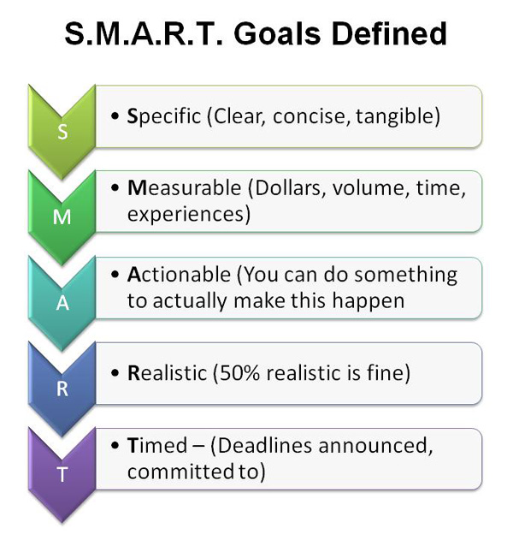

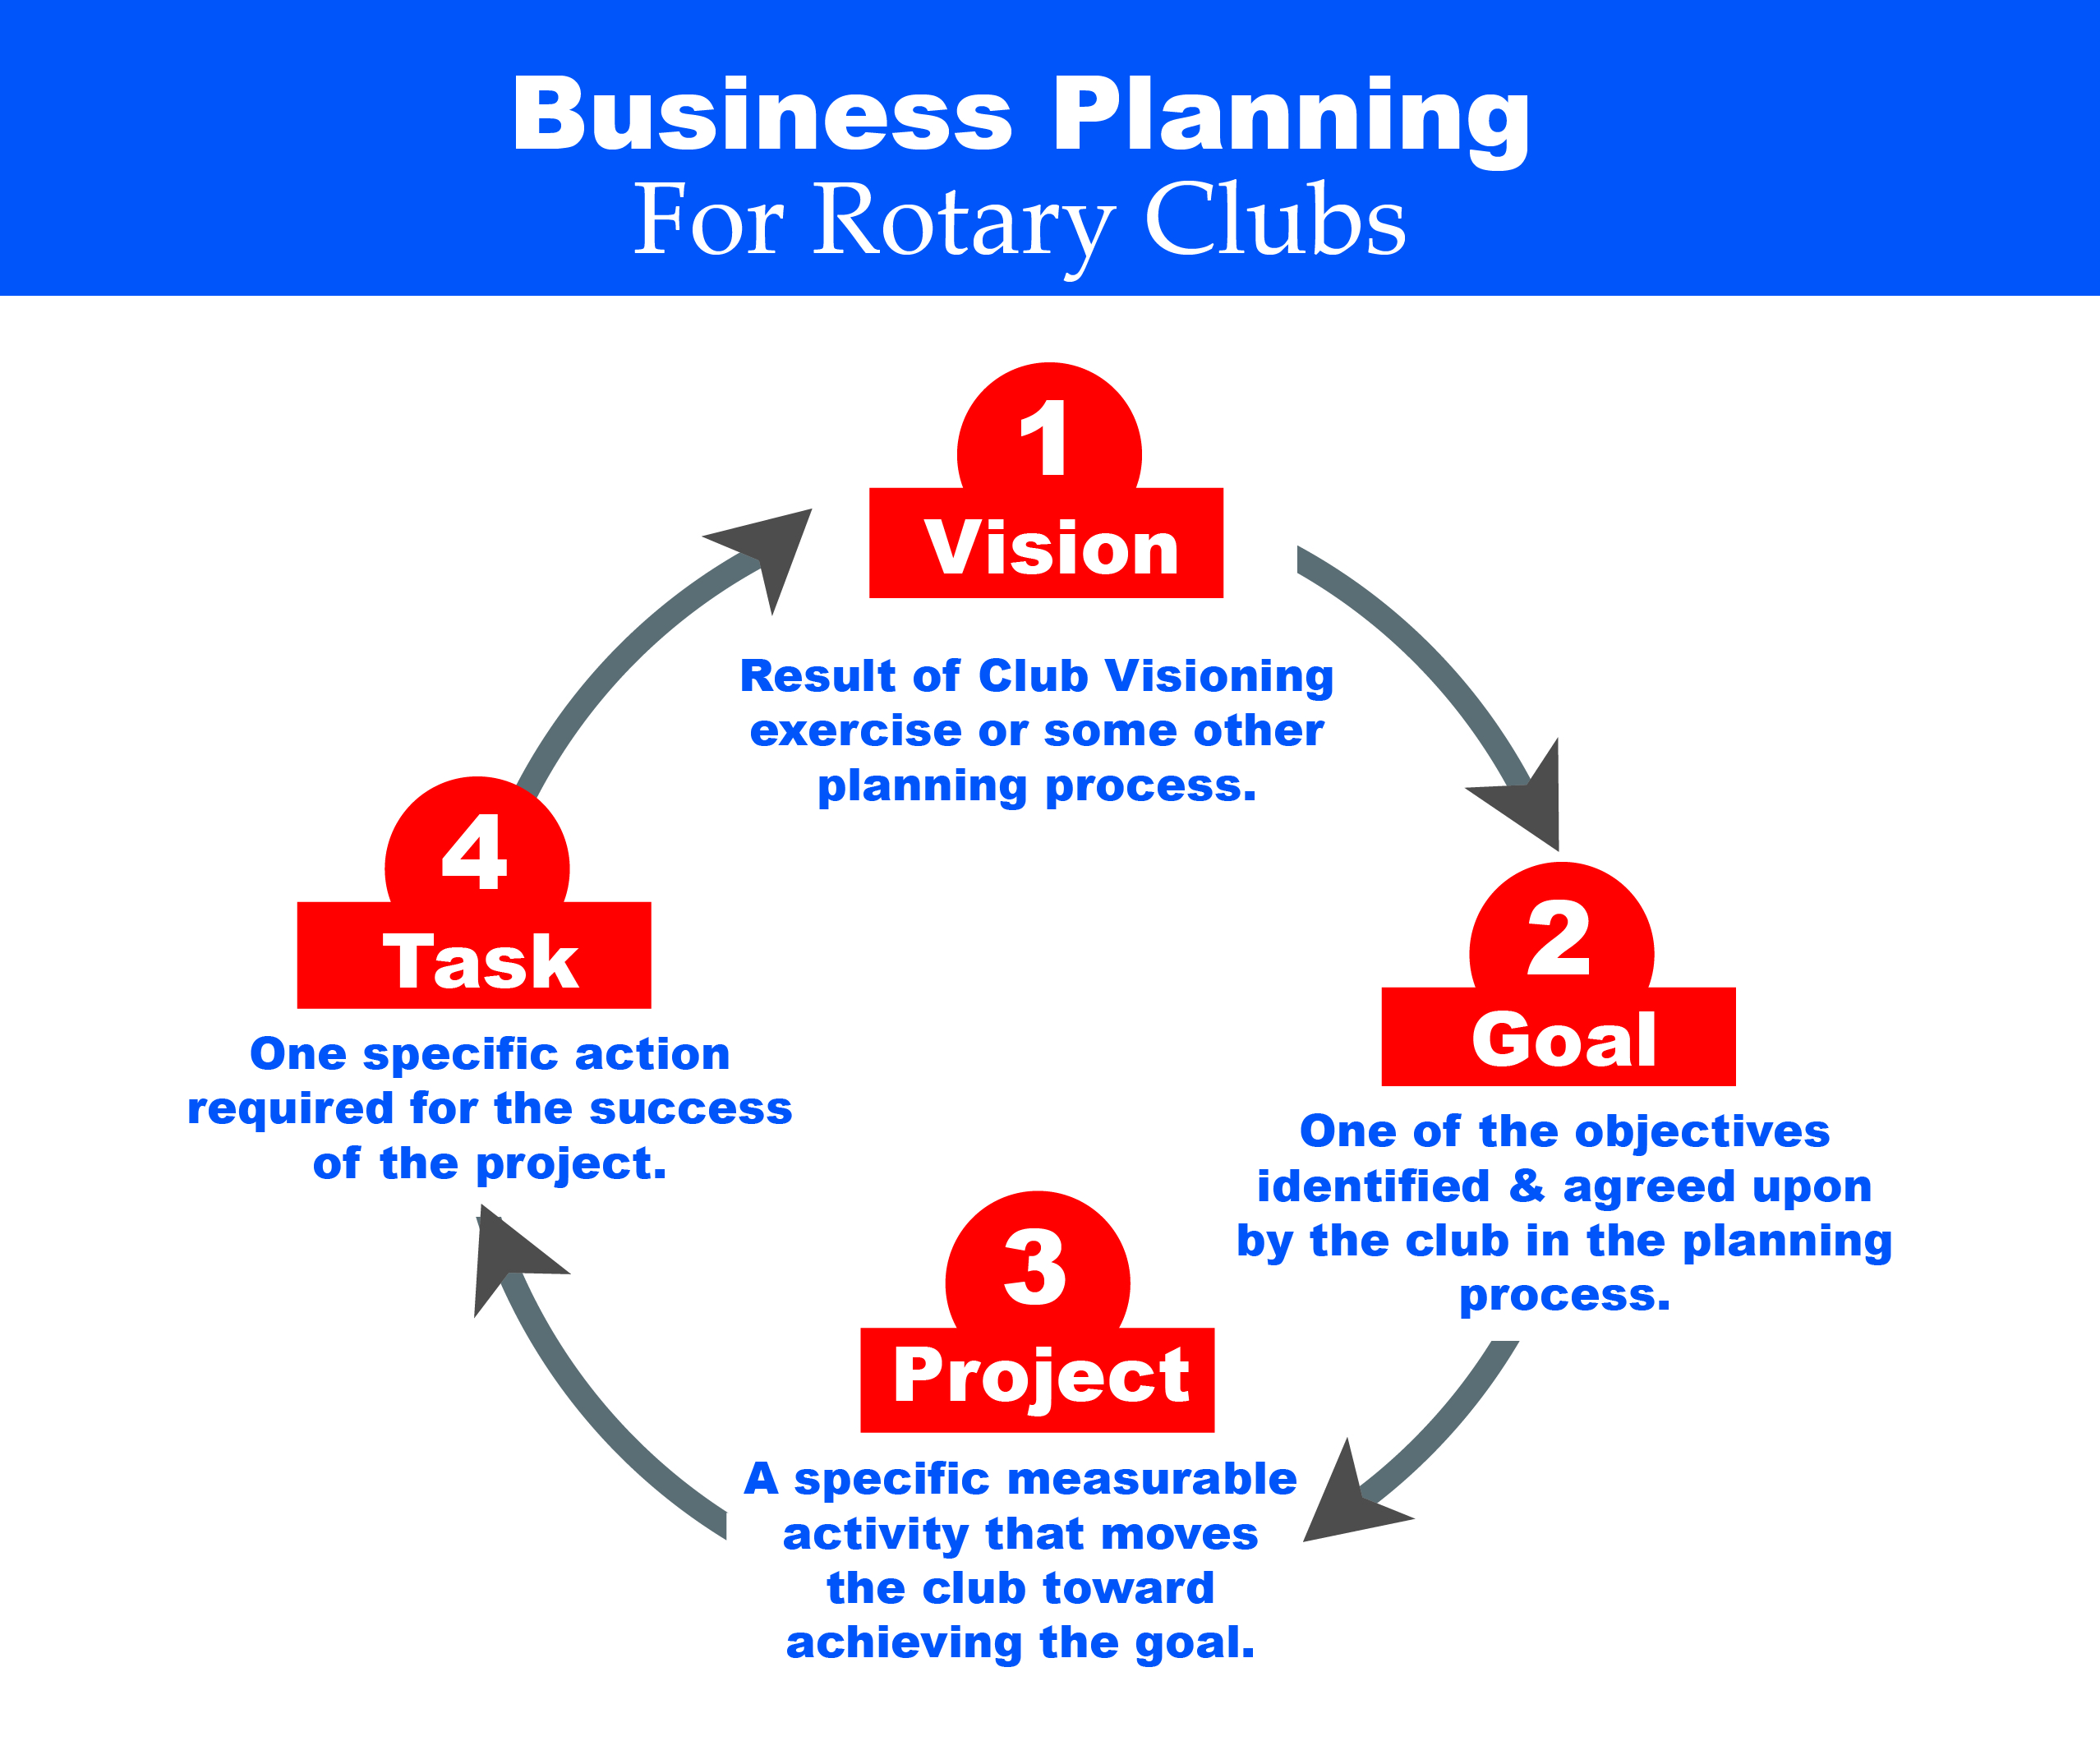

TRAIN THE TRAINER’s GUIDE
Curriculum for
Business Planning for Rotary Clubs

OVERVIEW

The Vision to Action Plan Seminar is a next step for a Club that has completed a process such as Club Visioning. To complete this seminar the club must have identified Strategic Initiatives that the club members have embraced for their Rotary Club. The club directors and officers will refer to these Strategic Initiatives to guide them in the creation of tactical Action Items that will be detailed within the Project Design Worksheet. Through the course of this seminar each officer, director and committee chair that participates will complete a Project Plan Worksheet for each of their major tactical planning areas providing them with a clear plan of action for this coming year.
In addition to the individual tactical plans created for each club leader as it relates to his or her position, the group works collectively on Membership which is considered to be a Shared Strategic Initiative and requires the involvement of all club leaders. These shared initiatives are planned for a three-year period and as part of the ongoing process the club would revisit and adjust these plans once each year.
The first step in participation is to identify Club Leadership who will participate in the seminar; in larger clubs this may include committee chairs. Some clubs may choose to engage committee chairs or other leaders responsible directly for an event or program that would benefit from the creation of tactical action plan defining the next steps.
Upon completion of the Project Design Worksheets the plan information will be entered into a website that provides confidential access to the club leadership, which will allow for progress against the tactical plans to be reported and then measured against the original timelines established.
INTRODUCTION

Action without vision is often wasted. Vision without action is just a dream. Rotary International President Luis Vicente Giay, 1996-97

Rotary leaders recognize the crucial role of effective planning for Rotary Club success. Many clubs and Districts have participated in a Vision Facilitation program that helped them define their missions, strengths, challenges, and especially, priorities. Such programs promote and include the necessity of follow-up action plans.

However, the vision work is often ignored or viewed as out of date. Without effective follow-up, a vision process may enthuse and enliven participants in the short term, yet generate few or none of the envisioned actions or results.

The goal of this Business Planning for Rotary Clubs program is to assist clubs to move from vision to action.

TRAIN THE TRAINERS GUIDE FOR CLUB BUSINESS PLANNING SESSION

PRE- SESSION

- Participants will be provided with the Rotary Club background and information from the club Vision Facilitation prior to the General Session

GENERAL SESSION

Session Set-Up:

- We use table rounds set in crescents
- Maximum 4 1/2 hours for the training session.
- Strategic initiatives from Visioning session, or other planning activity, are listed on charts posted around the room.

TIMELINE

Welcome & Intro 10 minutes
SMART Goals, Projects & Practices 20 minutes
Skills Training 70 minutes
Break 15 minutes
Skills Practice 75 minutes
Wrap-Up 30 minutes
220 total minutes

Welcome and Announcements, Introductions 10 minutes

Training leader’s notes

  - Welcome participants and identify any Rotary officials (governors, etc.)

  - Introduce your Team and yourself

  - Explain your roles as training leaders.

  - Review today’s agenda:
    - Brief overview of Business Planning Concepts
    - Skills Training
    - Skills Practice
    - Closure

  - State the purpose and intended results of this workshop: e.g., “To end this session with trained facilitators in Business Planning for Rotary Clubs (or Vision to Action Planning) who are able to confidently facilitate and assist clubs in moving from vision to action.”

SMART Goals, Projects, and Practices 20 Minutes

(Pass out SMART Goals sheets to participants)

Clubs can benefit from basic strategic planning concepts in a straightforward Business Planning for Rotary Clubs procedure, led by a small team of non-Club-member District leaders in a program of approximately three hours.

Such a program could:
- Be thorough yet uncluttered and easy to follow
- Take the club’s vision and create Tactical Action Plans

The planning seminar includes three basic segments:
- General skills in creating and writing action plans
- An exercise to develop a shared vision initiative for club membership
- Individual director/officer action plans in areas of responsibility

Club Goals are accomplishments that, once in place, further the Vision and take the club where it wants to go.

RHETORICAL QUESTIONS:

- Is there excitement and energy behind this? Are we eager to get going?

- What measurable results will we have? What impact? Can we envision them?

- Is it big enough to challenge us and arouse sustainable enthusiasm?

You are encouraging them to pick goals that they are really excited about.
Look for smiles, chatter, engagement.

Club Goals usually involve several projects. This is the art of ‘chunking down’ – dividing the aspects of our priorities into defined projects.

Most clubs have visions of being “excellent” or “providing life-changing service” . . . Goals flesh out what that looks like. What we DO to be “excellent” – what actual services change lives?

A project has a beginning, middle and an end. It is finite (unlike a Goal, which typically generates many projects that will overlap).

Achieving some Goals will involve instituting best Practices rather than, or in addition to, developing specific Projects. Practices are on-going activities that become part of the “culture” of the club.

Discuss SMART Goals (Specific, Measurable, Actionable, Realistic, and Timed).
The Goals established should be SMART Goals. Discuss the definitions of the terms, using the hand-out. Explain that, although there have been some other definitions in use in different settings, we have determined these definitions to be the most relevant for our Rotary clubs.

Skills Training: 70 Minutes
Share the examples of a personal strategic initiative and a Rotary Club strategic initiative to demonstrate the progress from Vision to Goal and then to Project. Hand-outs
Strategic Initiative to Goal:

Training Moment
Explain the techniques used from a number of Strategic Initiatives to define one Goal
Simple versus compound Goal
Apply SMART Goal Definitions
Stress the role of the presenter as COACH, providing guidance. (This role may be different from that of the Visioning Facilitator.)

Goal to Projects:
Training Moment
Discuss three projects ideas to be used in the exercise
Ensure that these are well defined and actionable
Follow the vocabulary

Projects to Tasks:

Demonstrate the development of a plan of action by defining the Tasks necessary to carry out the Project.

For each of the Tasks listed under a Project, it is necessary to determine:
- Intended results
- Key people and their roles
- Actions to take
- Time-line for those actions
- Budget implications

Training Moment
A Task contains specific actions
The Task needs to be simple and able to be monitored for progress
Ensure that at a minimum end dates are included

15 min Break

Skills Practice 75 minutes

Strategic Initiative to Goal:
Using the example of the Membership Vision of the sample club from the wall chart, suggest these SMART Goals (Strategic initiatives of Club size, attributes, and what we stand for in the community):
- Increase club membership by an average of one new member net per month by June 30, 2015
- Create more diversity in the club by having 50% females by June 2015
- Increase the membership of local industry members by 10% by June 2015

Goal to Projects:

Discuss different ways goals can be carried out
  - Projects
  - Specific Practices
  - Several Separate Projects

Run through examples so participants can clearly see difference.
Remind the group: All goals and projects are rooted in the club’s Vision/Mission and Language affects perception, and perception affects action

Suggest these Projects as appropriate for accomplishing Goal #1 above -

- Establish a marketing plan
- Establish an engagement plan
- Establish a community outreach plan

Projects to Tasks:
Divide the group into 3 smaller work groups. Have each work group develop the Tasks that would need to be identified for one of the Projects. They should use the concepts of the Vision to Action Plan Project Design Worksheet.

Have each group state the intended, measurable/observable outcomes of the project.

- Who will be accountable for the progress of the project?
- Who is involved in the project?
- What role does each play in the project?
Ask the group how they will motivate and sustain the motivation throughout the project.
Ask the group what the difference is between Delegation and Enrollment with Motivation in the context of accountability.

Using the example of Public Image from the Club Visioning results, have participants practice skills as follows:
Ask the group to identify some things that need to be put in place to complete the project.
Pick out from those ideas the ones that might be offshoot projects themselves.
Ask the group what issues and questions need to be resolved so that this project can be achieved.
Keep the participants focused on the future.
Ask the group to come up with a budget for the project.
Ask the group to Celebrate the successful completion of the project.
Have each group report on the Tasks for their Project, using the Worksheet, or the fillable PDF if available.
- From Project to Tasks
Post this Project - Develop a Social Media program for the club

Have a volunteer lead the group in listing possible Tasks that would be required for the success of this Project.

Conduct a critique of the list, including distinguishing some of the ideas that might be better identified as additional Projects.

Have one or two more volunteers do the same exercise with another Project such as
Create posters that can be used at meetings and service projects.

- From Goal to Project
Post this Goal derived from Public Image - By June 2014, develop a new website that will draw our members to use as a resource and that will inform and attract non-members

Have a volunteer lead the group in listing “those things that must be done” to move the club toward achieving this Goal.

Have the group identify one or two Projects that are listed, or that result from combining two or more of the items listed.

Discuss the difference between Projects and Tasks that appeared on the list.

- From Strategic Initiative to Goal
Go back to the Strategic Initiatives for Public Image. Post this Goal as an example of synthesizing the ideas in several of those initiatives:
By June 2014, develop a Public Image program for the club, including social media, print resources, and other items to increase our visibility in the community.

Have the group discuss whether or not this Goal is a SMART Goal. If not, how would they revise it?

Discuss the process of getting a global understanding of the initiatives listed for a Rotary area from Visioning, then developing one or more SMART Goals from that. (Discourage the temptation to just take each initiative and make it a Goal)

- Have a volunteer work with the group to develop one or more Goals, in the manner just described, from the Vocational Service initiatives posted.

Coach the leader and the group through this process.

If time permits, have another volunteer or two do the same exercise with The Rotary Foundation, Youth Service, Fund-raising, etc.

Wrap Up 30 Minutes
Congratulate the group on their accomplishments in facilitation and for undertaking this process with enthusiasm and dedication!

Discuss with the group the importance of documentation and on-going monitoring.

Discuss any follow-up procedures or activities that would be helpful for the participants.

VISION TO ACTION PLAN
PROJECT DESIGN WORKSHEET

VISION = Result of Club Visioning exercise or some other planning process
GOAL = One of the objectives identified and agreed upon by the club in the planning process
PROJECT = A specific measurable activity that moves the club toward achieving the GOAL
TASK = One specific action required for the success of the PROJECT
Rotarian serving as PROJECT MANAGER: _________________________________________________
Club Position: __________________________________________
Club Name: ____________________________________________
District: _______________________________________________
PROJECT NAME: ________________________________________
WHAT ARE THE INTENDED RESULTS OF THIS PROJECT?
_________________________________________________________________________________
_________________________________________________________________________________
_________________________________________________________________________________
WHAT ARE THE TASKS (ACTION ITEMS) REQUIRED TO COMPLETE THIS PROJECT?
Complete the sections below, one for each Task.
PROJECT NAME: ______________________________________________________________________
TASK #1 NAME: _______________________________________________________________________
DESCRIPTION OF TASK: _________________________________________________________________
START DATE: _______________________________________
COMPLETION DATE: _________________________________
LEAD MEMBER: ____________________________
OTHER MEMBERS: ___________________________ ______________________________
NON-MEMBERS: ___________________________ _______________________________________
BUDGET ITEMS:
ITEM: ______________________ AMOUNT : ________________________________
ITEM: ______________________ AMOUNT: _________________________________
ITEM: ______________________ AMOUNT: _________________________________
COMPLETION CONFIRMED (CHECK WHEN COMPLETE) ______________

PROJECT NAME: ______________________________________________________________________
TASK #2 NAME: _______________________________________________________________________
DESCRIPTION OF TASK: _________________________________________________________________
START DATE: _______________________________________
COMPLETION DATE: _________________________________
LEAD MEMBER: ____________________________
OTHER MEMBERS: ___________________________ ______________________________
NON-MEMBERS: ___________________________ _______________________________________
BUDGET ITEMS:
ITEM: ______________________ AMOUNT : ________________________________
ITEM: ______________________ AMOUNT: _________________________________
ITEM: ______________________ AMOUNT: _________________________________
COMPLETION CONFIRMED (CHECK WHEN COMPLETE) ______________
PROJECT NAME: ______________________________________________________________________
TASK #3 NAME: _______________________________________________________________________
DESCRIPTION OF TASK: _________________________________________________________________
START DATE: _______________________________________
COMPLETION DATE: _________________________________
LEAD MEMBER: ____________________________
OTHER MEMBERS: ___________________________ ______________________________
NON-MEMBERS: ___________________________ _______________________________________
BUDGET ITEMS:
ITEM: ______________________ AMOUNT : ________________________________
ITEM: ______________________ AMOUNT: _________________________________
ITEM: ______________________ AMOUNT: _________________________________
COMPLETION CONFIRMED (CHECK WHEN COMPLETE) ______________

PROJECT NAME: ______________________________________________________________________
TASK #4 NAME: _______________________________________________________________________
DESCRIPTION OF TASK: _________________________________________________________________
START DATE: _______________________________________
COMPLETION DATE: _________________________________
LEAD MEMBER: ____________________________
OTHER MEMBERS: ___________________________ ______________________________
NON-MEMBERS: ___________________________ _______________________________________
BUDGET ITEMS:
ITEM: ______________________ AMOUNT : ________________________________
ITEM: ______________________ AMOUNT: _________________________________
ITEM: ______________________ AMOUNT: _________________________________
COMPLETION CONFIRMED (CHECK WHEN COMPLETE) ______________
Notes: ______________________________________________________________________________________________________________________________________________________________________________________________________________________________________________________________________________________________________________________________________________________________________________________________________________________________________________________________________________________________________________________________
______________________________________________________________________________________________________________________________________________________________________________________________________________________________________________________________________________________________________________________________________________________________________________________________________________________________________________________________________________________________________________________________
______________________________________________________________________________________________________________________________________________________________________________________________________________________________________________________________________________________________________________________________________________________________________________________________________________________________________________________________________________________________________________________________
______________________________________________________________________________________________________________________________________________________________________________________________________________________________________________________________________________________________________________________________________________________________________________________________________________________________________________________________________________________________________________________________
____________________________________________________________________________________________________________________________________________________________________________________________________________________________________________________________________________________________________________________________________________________________________________________________________________________________________________________________________________________________________________________________________________________________________________________________________________________________________________________________________________________________________________________________________________________________________________________________________________________________________________________________________________________________________________________________________________________________________________________________________________________________________________________________
_____________________________________________________________________________________
_____________________________________________________________________________________

